## **Total Loan Application**

SELECT COUNT(DISTINCT(id)) FROM bank_loan_data;



SELECT COUNT(id) as Decemeber_MoM FROM bank_loan_data

WHERE MONTH(issue_date) = 12 AND YEAR(issue_date) = 2021;



SELECT COUNT(id) as Loan_Application_PMTD FROM bank_loan_data

WHERE MONTH(issue_date) = 11 AND YEAR(issue_date) = 2021;



## **Total Funded Amount**

SELECT SUM(loan_amount) as Total_Funded_Amount FROM bank_loan_data;



SELECT SUM(loan_amount) as Total_Funded_Amount FROM bank_loan_data

WHERE MONTH(issue_date) = 12;



SELECT SUM(loan_amount) as Total_Funded_Amount_PMTD

FROM bank_loan_data

WHERE MONTH(issue_date) = 11;



## **Total Amount Received**

SELECT SUM(total_payment) as Total_Amount_Received

FROM bank_loan_data;



SELECT SUM(total_payment) as Total_Amount_Received_MTD

FROM bank_loan_data

WHERE MONTH(issue_date) = 12;



SELECT SUM(total_payment) as Total_Amount_Received_PMTD

FROM bank_loan_data

WHERE MONTH(issue_date) = 11;



## **Average Interest Rate**

*100 to get it in percentage

SELECT ROUND(AVG(int_rate),4) as Average_Interest_Rate

FROM bank_loan_data;



SELECT ROUND(AVG(int_rate),4) as Average_Interest_Rate_MTD

FROM bank_loan_data

WHERE MONTH(issue_date) = 12;



SELECT ROUND(AVG(int_rate),4) as Average_Interest_Rate_PMTD

FROM bank_loan_data

WHERE MONTH(issue_date) = 11;



## **Average DTI**

SELECT ROUND(AVG(dti),4) as Average_DTI

FROM bank_loan_data;



SELECT ROUND(AVG(dti),4) as Avg_DTI_MTD

FROM bank_loan_data

WHERE MONTH(issue_date) = 12;



SELECT ROUND(AVG(dti),4) as Avg_DTI_PMTD

FROM bank_loan_data

WHERE MONTH(issue_date) = 11;



## **Good Loans**

SELECT COUNT(id) AS good_loans

FROM bank_loan_data

WHERE loan_status = 'Fully Paid' OR loan_status = 'Current';



SELECT

(COUNT(CASE WHEN loan_status = 'Fully Paid' OR loan_status = 'Current' THEN id END)*100)

/COUNT(id) as good_loan_perc

FROM bank_loan_data;



SELECT SUM(loan_amount) AS good_loan_fund_amount

FROM bank_loan_data

WHERE loan_status = 'Fully Paid' OR loan_status = 'Current';



SELECT SUM(total_payment) AS good_loan_payment_amount

FROM bank_loan_data

WHERE loan_status = 'Fully Paid' OR loan_status = 'Current';



## **Bad Loan**

SELECT COUNT(id) as bad_loan_count FROM bank_loan_data

WHERE loan_status = 'Charged Off';



SELECT (COUNT(CASE WHEN loan_status = 'Charged Off' THEN id END)*100.0)

/

COUNT(id) as bad_loan_percentage

FROM bank_loan_data;



SELECT SUM(total_payment) as bad_loan_payment FROM bank_loan_data

WHERE loan_status = 'Charged Off';

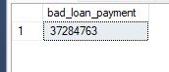

**Loan Status Grid**

SELECT loan_status,

COUNT(id) as loan_count,

SUM(loan_amount) as loan_amount_funded,

SUM(total_payment) as loan_payment_back,

AVG(int_rate)*100 as interest_rate_perc,

AVG(dti)*100 as dti_perc

FROM bank_loan_data

GROUP BY loan_status;

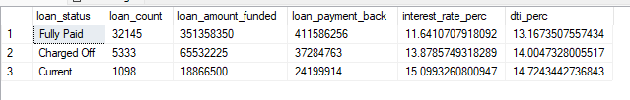

## **Monthly Trends by Issue Date**

SELECT MONTH(issue_date) as monthly_trend,

COUNT(id) as Total_Loan_Count,

SUM(loan_amount) as Total_Funded_Amount,

SUM(total_Payment) as Total_Amount_Received

FROM bank_loan_data

GROUP BY MONTH(issue_date)

ORDER BY monthly_trend;

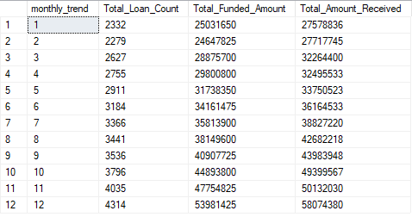

## **Regional Analysis by State**

SELECT address_state as State_Name,

COUNT(id) as Total_Loan_Count,

SUM(loan_amount) as Total_Funded_Amount,

SUM(total_Payment) as Total_Amount_Received

FROM bank_loan_data

GROUP BY address_state;

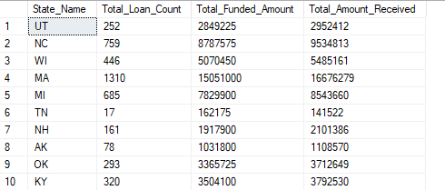

## **Loan Term Analysis**

SELECT term as Loan_Duration,

COUNT(id) as Total_Loan_Count,

SUM(loan_amount) as Total_Funded_Amount,

SUM(total_Payment) as Total_Amount_Received

FROM bank_loan_data

GROUP BY term;

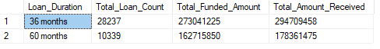

## **Employment Term Analysis**

SELECT emp_length as Employment_Duration,

COUNT(id) as Total_Loan_Count,

SUM(loan_amount) as Total_Funded_Amount,

SUM(total_Payment) as Total_Amount_Received

FROM bank_loan_data

GROUP BY emp_length;

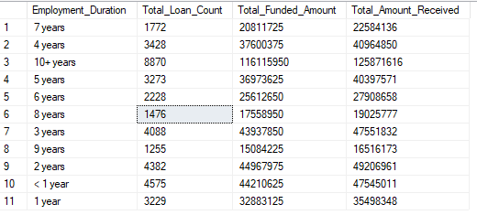

## **Loan Purpose Breakdown**

SELECT purpose,

COUNT(id) as Total_Loan_Count,

SUM(loan_amount) as Total_Funded_Amount,

SUM(total_Payment) as Total_Amount_Received

FROM bank_loan_data

GROUP BY purpose

ORDER BY COUNT(id) DESC;

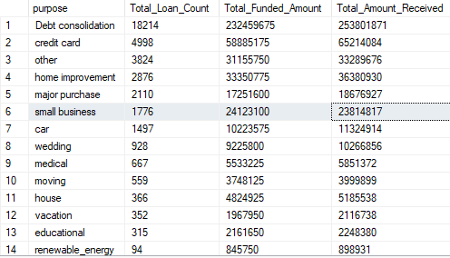

## **Home ownership analysis**

SELECT home_ownership,

COUNT(id) as Total_Loan_Count,

SUM(loan_amount) as Total_Funded_Amount,

SUM(total_Payment) as Total_Amount_Received

FROM bank_loan_data

GROUP BY home_ownership

ORDER BY COUNT(id) DESC;

